LearnHub – MERN Full Stack Project Documentation

1. Introduction
Project Title:
LearnHub: Your Center for Skill Enhancement
Team Members:
- Mooli Bindu Sai – Team Leader, Backend Development, API Development
- Team Member 2 – Frontend Development (React UI)
- Team Member 3 – Database Design & Testing

2. Project Overview
Purpose
LearnHub is an Online Learning Platform (OLP) developed using the MERN stack (MongoDB, Express.js, React.js, Node.js). The purpose of this platform is to provide a centralized system where students can browse courses, enroll in them, and learn new skills online.
The system allows instructors to upload and manage courses, while students can learn at their own pace.
Features
- User Registration and Login
- Course Browsing and Searching
- Course Enrollment
- Student Dashboard
- Teacher Dashboard
- Admin Dashboard
- Course Progress Tracking
- Certificate Generation
- Secure Authentication using JWT
- Responsive User Interface

3. Architecture
The LearnHub platform follows a client-server architecture.
Frontend (React.js)
The frontend is built using React.js and provides an interactive user interface for students, teachers, and administrators.
Technologies used:
- React.js
- Bootstrap
- Material UI
- Axios
- Ant Design
Responsibilities:
- Display course information
- Manage user interaction
- Send API requests to backend
- Display dashboards and course content

Backend (Node.js + Express.js)
The backend is built using Node.js and Express.js.
Responsibilities:
- Handle API requests
- Manage authentication and authorization
- Handle course management
- Process enrollments
- Connect frontend with database
Libraries used:
- Express.js
- bcryptjs
- jsonwebtoken
- cors
- multer
- dotenv
- nodemon

Database (MongoDB)
The project uses MongoDB, a NoSQL database that stores data in JSON format.
Collections Used
Users Collection
Fields:
- _id
- name
- email
- password
- type (student / teacher / admin)
Courses Collection
Fields:
- _id
- userID (teacher ID)
- C_educator
- C_categories
- C_title
- C_description
- sections
- C_price
- enrolled
MongoDB ensures scalable and efficient data storage.

1️⃣ LearnHub System Architecture Diagram
2️⃣ LearnHub ER Diagram (Database Diagram)
3️⃣ LearnHub Project Flow Diagram

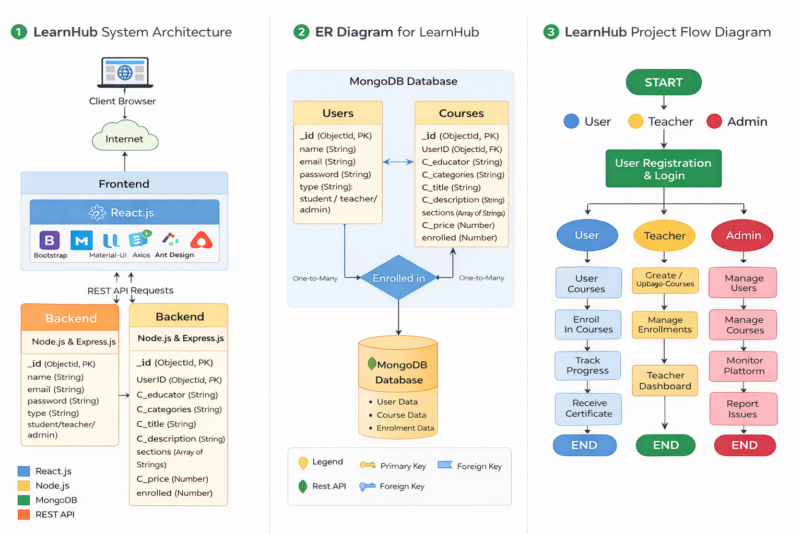

4. Setup Instructions
Prerequisites
The following software must be installed before running the project:
- Node.js
- npm
- MongoDB
- Git
- Visual Studio Code
- Vite
- React.js
Basic knowledge required:
- HTML
- CSS
- JavaScript
- Database Connectivity

Installation Steps
Step 1 – Clone Repository
git clone https://github.com/MBindusai1403/learnhub.git
Step 2 – Navigate to Project Folder
cd learnhub
Step 3 – Install Dependencies
Backend:
cd backend
npm install
Frontend:
cd frontend
npm install
Step 4 – Configure Environment Variables
Create .env file:
PORT=5000
MONGO_URI=your_mongodb_connection
JWT_SECRET=your_secret_key

5. Folder Structure
Client (Frontend)
Frontend folder contains all UI related components.
Example structure:
frontend
│
├── src
│ ├── components
│ ├── pages
│ ├── services
│ ├── App.js
│ └── index.js
│
├── package.json
Responsibilities:
- UI rendering
- API calls
- User interaction

Server (Backend)
Backend folder manages server logic and APIs.
Example structure:
backend
│
├── config
│ └── db.js
│
├── middleware
│ └── authMiddleware.js
│
├── models
│ ├── User.js
│ └── Course.js
│
├── routes
│ ├── authRoutes.js
│ ├── courseRoutes.js
│ └── enrollmentRoutes.js
│
├── server.js
└── package.json
Responsibilities:
- API handling
- Authentication
- Database interaction

6. Running the Application
Backend Server
Run backend server:
cd backend
npm start
Server runs at:
http://localhost:5000

Frontend Server
Run frontend server:
cd frontend
npm start
Frontend runs at:
http://localhost:5172

7. API Documentation
Authentication APIs
Register User
POST /api/auth/register
Request Body:
{
"name": "bindu",
"email": "bindu123@email.com",
"password": "123@"
}
Response:
User registered successfully

Login User
POST /api/auth/login
Response:
JWT Token generated

Course APIs
Get All Courses
GET /api/courses
Add Course
POST /api/courses
Delete Course
DELETE /api/courses/:id

Enrollment APIs
Enroll Course
POST /api/enroll
Get Enrolled Courses
GET /api/enroll/:userId

8. Authentication
Authentication is implemented using JSON Web Tokens (JWT).
Process:
- User logs in.
- Server verifies credentials.
- Server generates a JWT token.
- Token is sent to client.
- Client sends token in headers for protected APIs.
Middleware verifies token before allowing access to secure routes.

9. User Interface
The platform contains multiple UI interfaces:
- Landing Page
- Register Page
- Login Page
- Student Dashboard
- Teacher Dashboard
- Admin Dashboard
The UI is built using React.js, Bootstrap, and Material UI.

10. Testing
Testing was performed using:
- Postman for API testing
- Manual testing for UI functionality
- Error handling validation
Testing ensures that:
- APIs work correctly
- User authentication works
- Course enrollment works

11. Screenshots / Demo
Screenshots included in documentation:
- Landing Page
- Register Page
- Login Page
- Student Dashboard
- Teacher Dashboard
- Admin Dashboard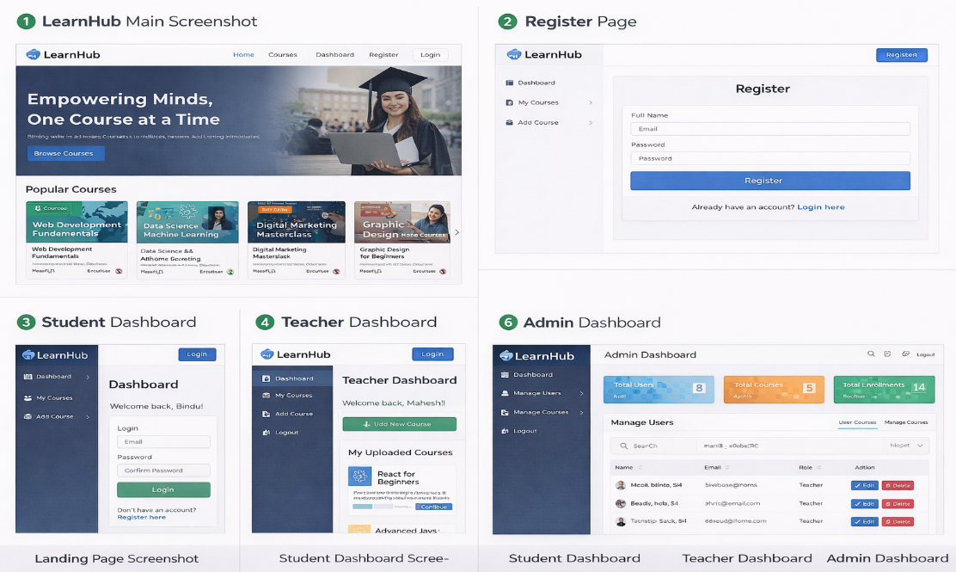

Demo Video:
Project Implementation Video

12. Known Issues
- UI responsiveness can be improved
- Course search optimization required
- Minor validation improvements needed

13. Future Enhancements
Future improvements include:
- Online video streaming for courses
- Payment gateway integration
- Certificate generation automation
- Mobile application support
- AI-based course recommendations

